[Category]

Question 01 (MC)
[Question text] |  |  | MC
Default mark: |  |  | 1
Shuffle the choices? |  |  | Yes
Number the choices? |  |  | A
Penalty for each incorrect try: |  |  | 33.3
# | Answers | Feedback | Grade
 |  |  | 100
 |  |  | 0
 |  |  | 0
 |  |  | 0
 |  |  | 0

Question 02 (MA)
[Question text] |  |  | MA
Default mark: |  |  | 1
Shuffle the choices? |  |  | Yes
Number the choices? |  |  | A
Show the number of correct responses once the question has finished: |  |  | No
Penalty for each incorrect try: |  |  | 33.3
# | Answers | Feedback | Grade
 |  |  | 0
 |  |  | 50
 |  |  | 50
 |  |  | 0
 |  |  | 0

Question 03 (MS)
[Question text] |  |  | MS
Default mark: |  |  | 1
Shuffle the choices? |  |  | Yes
Number the choices? |  |  | A
Show the number of correct responses: |  |  | No
Penalty for each incorrect try: |  |  | 33.3
# | Answers | Feedback | Grade
 |  |  | 100
 |  |  | 100
 |  |  | 0
 |  |  | 0
 |  |  | 0

Question 04 (MAT)
[Question text] |  |  | MAT
Default mark: |  |  | 1
Shuffle: |  |  | Yes
Show the number of correct responses once the question has finished: |  |  | No
Penalty for each incorrect try: |  |  | 33.3
# | Question | Answer

Question 05 (TF)
[Question text] |  |  | TF
Default mark: |  |  | 1
 | Answers | Feedback | Grade
 | True |  | 100
 | False |  | 0

Question 06 (SA)
[Question text] |  |  | SA
Default mark: |  |  | 1
Case sensitivity: |  |  | No
Penalty for each incorrect try: |  |  | 33.3
 | Answers | Feedback | Grade
 |  |  | 100
 | * |  | 0
 | General feedback:
You must provide at least one possible answer. Answers left blank will not be used. '*' can be used as a wildcard to match any characters. The first matching answer will be used to determine the score and feedback.

Question 07 (ES)
[Question text] |  |  | ES
Default mark: |  |  | 1
Response format: |  |  | HTML editor with file picker
Require text: |  |  | Yes
Input box size: |  |  | 15
Allow attachments: |  |  | 0
Require attachments: |  |  | 0
 | Response template | Information for graders
 | Any text entered here will be displayed in the response input box when a new attempt at the question starts.
 | General feedback:
 | Tags:
Allows a response of a few sentences or paragraphs. This must then be graded manually.

Question 08 (Numerical - CL)
FairKart India is deciding on Inventory policy and is evaluating the FIFO and weighted average method as per the following data. Assuming sale value of the goods sold is INR 5000, what will be the gross margin [ (sale value of the goods – cost of the goods sold)/Sale value of the goods] under FIFO and weighted average method respectively in percent are 37 and 30.4 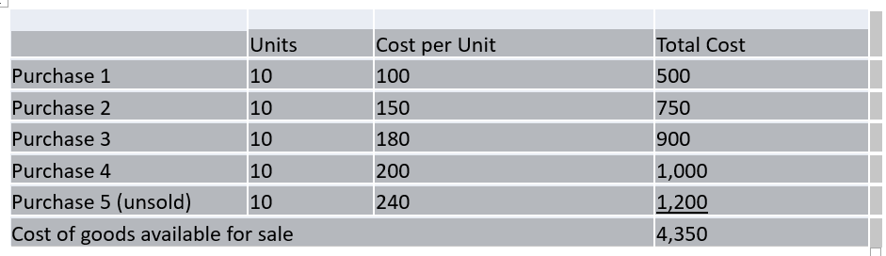 |  |  | CL
Default mark: |  |  | 1
Case sensitivity: |  |  | No
Penalty for each incorrect try: |  |  | 33.3
 | Answers | Feedback | Grade
 |  |  | 100
 | * |  | 0
 | General feedback:

Question 09 (Shortanswer - CL)
The companies are expected to provide all the relevant information along with the financials in AnnualReport |  |  | CL
Default mark: |  |  | 1
Case sensitivity: |  |  | No
Penalty for each incorrect try: |  |  | 33.3
 | Answers | Feedback | Grade
 | General feedback:

